**UNIT-1**

**INTRODUCTION**

***Communication***is the process of exchanging information. People communicate to convey their thoughts, ideas, and feelings to others. The process of communication is inherent to all human life and includes verbal, nonverbal (body language), print, and electronic processes. Communication between early human beings was limited to face-to-face encounters. Long-distance communication was first accomplished by sending simple signals such as drumbeats, horn blasts, and smoke signals and later by waving signal flags. When messages were relayed from one location to another, even greater distances could be covered.

The distance over which communication could be sent was extended by the written word. For many years, long-distance communication was limited to the sending of verbal or written messages by human runner, horseback, ship, and later trains.

Human communication took a dramatic leap forward in the late nineteenth century when electricity was discovered and its many applications were explored. The telegraph was invented in 1844 and the telephone in 1876. Radio was discovered in 1887 and demonstrated in 1895.

Well-known forms of electronic communication, such as the telephone, radio, TV and the Internet, have increased our ability to share information. The way we do things and the success of our work and personal lives are directly related to how well we communicate. It has been said that the emphasis in our society has now shifted from that of manufacturing and mass production of goods to the accumulation, packaging, and exchange of information. Ours is an information society, and a key part of it is communication .Without electronic

communication, we could not access and apply the available information in a timely way.

**Communication System**

All electronic communication systems have a transmitter, a communication channel or medium, and a receiver. These basic components are shown in fig below:

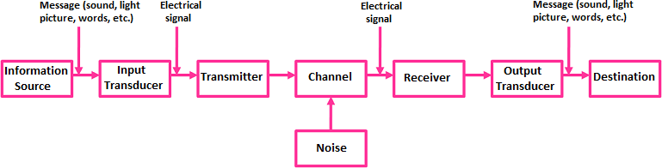

**Information Source:**

The communication system establishes the communication bridge between the sender (transmitter) and receiver. To establish this communication bridge between the sender and receiver, we need information to send. This information originates in the information source. The information generated by the source may be in the form of sound (human speech), picture (image source), and words (plain text in some particular language such as English, French, and German etc.) For example, if you are talking with your friend on a phone, you are considered as the information source who generates information in the form of sound.

**Input Transducer**:

If you want to talk (communicate) with your friend who is sitting beside you, then you can directly talk with him by using voice signals (sound signals). But if the same friend is farther away from you, then you can’t directly communicate with him by using voice signals (sound signals) because sound signals cannot travel larger distances. So in order to overcome this problem and transmit information to larger distances, we need to convert this sound signal into another form of signal (electrical signal or light signal) which travel larger distances.

The device which is used to convert this sound signal into another form of signal is called transducer. A transducer is a device which converts one form of energy or signal into another form of energy or signal. The transducer is present at the input side and output side of the communication system. The transducer that is present at the input side of the communication system is called input transducer. Generally, the input transducer converts the non-electrical signal (sound signal or light signal) into an electrical signal. The best example of an input transducer is the microphone which is placed between the information source and the transmitter section. A microphone is a device which converts the voice signals (sound signals) into electrical signals.

**Transmitter:**

The transmitter is a collection of electronic components and circuits designed to convert the electrical signal to a signal suitable for transmission over a given communication medium. Transmitters use a technique called modulation to convert the electrical signal into a form that is suitable for transmission over a given channel or medium. Modulation is the main function of a transmitter.

In order to send the signals to larger distances, without the effect of any external interferences or noise addition and without getting faded away, it has to undergo a process called modulation. Modulation increases the strength of a signal without changing the parameters of the original signal.

**Channel:**

The communication channelis the medium by which the electronic signal is sent from one place to another. Many different types of media are used in communication systems, including wire conductors, fiber-optic cable, and free space.

1. **Electrical Conductors:** In its simplest form, the medium may simply be a pair of wires that carry a voice signal from a microphone to a headset. It may be a coaxial cable such as that used to carry cable TV signals or it may be a twisted-pair cable used in a local area network (LAN).
2. **Optical Media.** The communication medium may also be a fiber-optic cable or “light pipe” that carries the message on a light wave. These are widely used today to carry long-distance calls and all Internet communications. The information is converted to digital form that can be used to turn a laser diode off and on at high speeds.
3. **Free Space.** When free space is the medium, the resulting system is known as radio also known *as* wireless, radiois the broad general term applied to any form of wireless communication from one point to another. Radio makes use of the electromagnetic spectrum. Information signals are converted to electric and magnetic fields that

propagate nearly instantaneously through space over long distances.

**Noise:**

Noise is an unwanted signal that enters the communication system via the communication channel and interferes with the transmitted signal. The noise signal (unwanted signal) degrades the transmitted signal (signal containing information).

**Receiver:**

A receiveris a collection of electronic components and circuits that accepts the transmitted message from the channel and converts it back to a form understandable by humans. TV set is a good example of a receiver. TV set receives the signals sent by the TV transmitting stations and converts the signal into a form which is easily understandable by the humans who are watching TV.

**Output Transducer:**

The transducer that is present at the output side of the communication system is called output transducer. Generally, the output transducer converts the electrical signal into a non-electrical signal (sound signal, light signal, or both sound and light signal). The best example of an output transducer is the loudspeaker which is placed between the receiver section and the destination. The loudspeaker converts the electrical signals into sound signals which are easily understandable by the humans at the destination.

**Destination:**

The destination is the final stage in the communication system. Generally, humans at some place are considered as the destination. A destination is a place where humans consume the information. For example, if we are watching TV, we are considered as destination.

**ELECTROMAGNETIC SPECTRUM**

Electromagnetic waves are signals that oscillate; i.e., the amplitudes of the electric and magnetic fields vary at a specific rate. The field intensities fluctuate up and down, and the polarity reverses a given number of times per second. The electromagnetic waves vary sinusoidally. Their frequency is measured in cycles per second (cps) or hertz (Hz).

These oscillations may occur at a very low frequency or at an extremely high frequency. The range of electromagnetic signals encompassing all frequencies is referred to as the electromagnetic spectrum. The electromagnetic spectrum is shown in figure below:

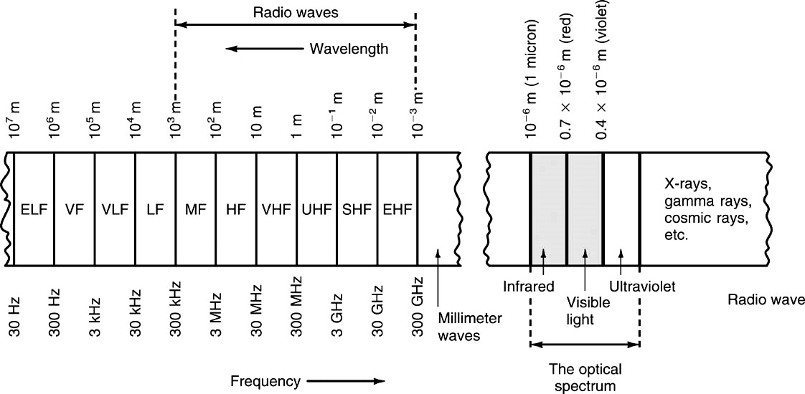

**Infrared radiation** are electromagnetic radiations between 300 GHz to 400 THz (G=109 and T=1012) frequency and with wavelengths in the range 750nm (n=10-9) to 1mm (m=10-3) longer than visible light. It is used for heating such as in infrared saunas (used for treatment of health problems) and for night vision.

**Visible light**have frequency from 400 THz to 790 THz frequency and wavelengths of around 750 nm - 380 nm. It is the only form of electromagnetic radiation that can be seen by the human eye and includes the colours of the rainbow. It is used for illumination such as in light bulbs and for photography.

The seven colours of visible light from shortest to longest wavelength are given below:

1. **Violet** - shortest wavelength, around 380-450 nanometres with highest frequency. They carry the most energy.
2. **Indigo** - 420 - 440 nm
3. **Blue** - 450 - 495 nm
4. **Green** - 495 - 570 nm
5. **Yellow** - 570 - 590 nm
6. **Orange** - 590 - 620 nm
7. **Red** - longest wavelength, at around 620 - 750 nanometres with lowest frequency

**The visible lights are used in electronic gadgets, photography, and fiber optic communications**

**Ultraviolet radiation** have shorter wavelengths than visible light, in the order of 380 nm -10 nm with a frequency range from 790 THz to 30 PHz( P=1015). It is used for tanning (UV exposure increases melanin pigment in our skin), sterilization such as in hospitals and for exposing faults in a material through fluorescence (the ability of certain materials to give off visible light after absorbing UV light).

**X-rays** are in the frequency range of 30 PHz (P=1015) to 30 EHz (E=1018) and have shorter wavelengths than ultraviolet radiation, which ranges from 10 nm to 10 pm (p=10-12). They are used for medical imaging, such as X- rays and CT scans and research in fields such as materials science.

**Gamma rays** have the highest frequency range (greater than 30EHz) and shortest wavelengths (less than 10 pm). They are used for medical treatments, such as cancer radiation therapy, and for research such as imaging and material analysis.

**Frequency Ranges from 30 Hz to 300 GHz**

|  |  |
| --- | --- |
| Extremely Low Frequencies (ELF) | 30–300 Hz. |
| Voice Frequencies (VF) | 300–3000 Hz. |
| Very Low Frequencies (VLF) | Include the higher end of the human hearing range up to about 20 kHz. |
| Low Frequencies (LF) | 30k–300 kHz. |
| Medium Frequencies (MF) | 300k–3000 kHz  AM radio 535k–1605 kHz. |
| High Frequencies (HF)  (short waves)Voice Of America (VOA), BBC broadcasts; government and military two-way communication; amateur radio, Citizens band radio (CB). | 3M–30 MHz |
| Very High Frequencies (VHF)  FM radio broadcasting (88–108 MHz), television channels 2–13. | 30M–300 MHz |
| Ultra High Frequencies (UHF)  TV channels 14–67, cellular phones and military communication. | 300M–3000 MHz |
| Microwaves and Super High Frequencies(SHF) Satellite communication, radar, wireless LANs, microwave ovens | 1G–30 GHz |
| Extremely High Frequencies (EHF)  Satellite communication, computer data, radar | 30G–300 GHz |

**FREQUENCY AND WAVELENGTH**

**Frequency (f)**is the number of times a particular phenomenon occurs in a

given period of time. In electronics, frequency is the number of cycles of a repetitive wave that occurs in a given time period. It is expressed in Hertz (Hz).

**Wavelength (**λ**)** is the distance occupied by one cycle of a wave and it

is usually expressed in meters (m).

**1m=3.28ft= 39.37in**

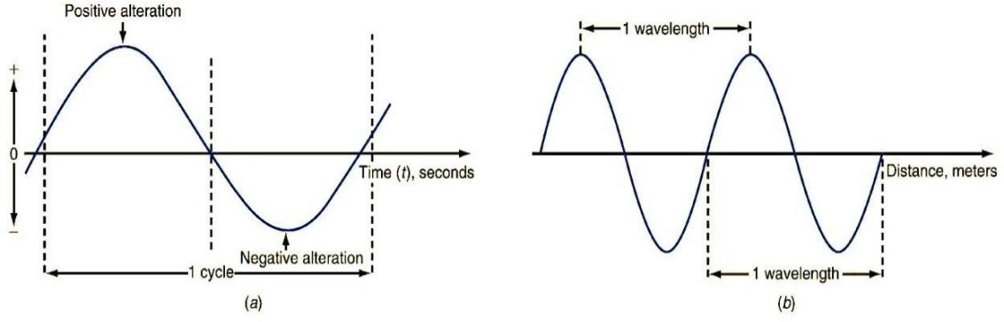

**Representation of Frequency & Wavelength**

**\**

The relation between the frequency (f), wavelength (λ) and the velocity of

electromagnetic wave (v) is given by

**v=f x λ v=**3x108 m/s

**Ex:** A signal travels a distance of 75ft in the time it takes to complete 1 cycle. What is its frequency?

v=3x108 m/s

**Sol: λ**= 75ft

1 m = 3.28 ft

1ft= (1) ÷ (3.28) = 0.305m

**λ =**75ft= 75x0.305m=22.875m

Frequency (f) = v/ **λ =** 13.12 MHz

**GAIN, ATTENUATION AND DECIBELS**

Most electronic circuits in communication are used to process signals, i.e ., to manipulate signals to produce a desired result. All signal processing circuits involve either gain or attenuation.

**GAIN**

Gainmeans amplification. If a signal is applied to a circuit such as the amplifier and the output of the circuit has a greater amplitude than the input signal, the circuit has gain. Gain is simply the ratio of the output to the input. For input (Vin)and output (Vout)voltages, voltage gain AVis expressed as follows:

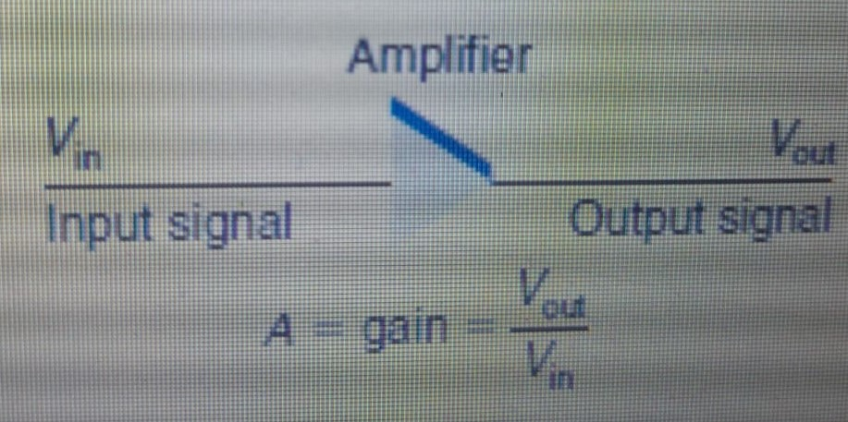

AV*=* output voltage=Vout

input voltage Vin

The number obtained by dividing the output by the input shows how much larger the output is than the input. For example, if the input is 150 *μ*V and the output is 75 mV, the gain is

AV= 75x10-3 =500

150x10-6

The formula can be rearranged to obtain the input or the output, given the other two variables: Vout =Vin x AVand Vin = Vout / AV.

If the output is 0.6 V and the gain is 240, the input is Vin = 0.6/240 =

2.5 x 10 -3 = 2.5 mV.

**Ex:** What is the voltage gain of an amplifier that produces an output of 750 mV for a 30-*μ*V input?

**Sol:**  AV*=* output voltage=Vout

input voltage Vin

**=**  750x10-3= 25,000

30x10-6

Since most amplifiers are also power amplifiers, the same procedure can be used to calculate power gain AP

AP= output power=Pout

input power Pin

where Pin is the power input and Pout is the power output

**Ex:** The power output of an amplifier is 6 watts (W). The power gain is 80.

What is the input power?

**Sol:** AP = output power =Pout

input power Pin

Therefore Input power= output power= 6 = 0.075W=75mW

AP 80

When two or more stages of amplification or other forms of signal processing are cascaded, the overall gain of the combination is the product of the individual circuit gains.

The figure shows three amplifiers connected one after the other so that the output of one is the input to the next. The voltage gains of the individual circuits are marked. To find the total gain, simply multiply the individual circuit gains:

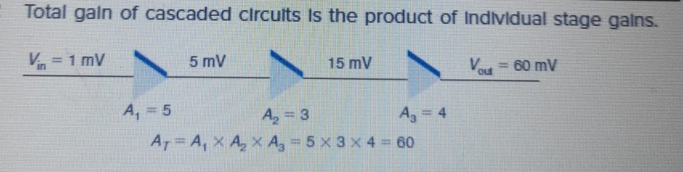

If an input signal of 1 mV is applied to the first amplifier, the output of the third amplifier will be 60 mV. The outputs of the individual amplifiers depend upon their individual gains.

**Ex:** A two-stage amplifier has an input power of 25 *μ*W and an output power of 1.5 mW. One stage has a gain of 3. What is the gain of the second stage?

**Sol:** Since it is a two stage amplifier, let A1 and A2 be the power gains of 1st stage and 2nd stage respectively and AP be the overall power gain of the two stage amplifier.

A1=3; A2=?

Input power to the two stage amplifier=Pin=25 *μ*W

Ouput power from the two stage amplifier=Pout=1.5 *m*W

The overall power gain of the two stage amplifier ,AP= A1x A2=3A2

AP = output power =Pout= 1.5x10-3=60

input power Pin 25x10-6

3A2=60

A2=2

**ATTENUATION**

Attenuationrefers to a loss introduced by a circuit or component. Many electronic circuits sometimes called stages, reduce the amplitude of a signal rather than increase it. If the output signal is lower in amplitude than the input, the circuit has loss, or attenuation. Like gain, attenuation is simply the ratio of the output to the input. The letter **A**is used to represent attenuation as well as gain

.

Attenuation, A*=* output voltage=Vout

input voltage Vin

Circuits that introduce attenuation have a gain that is less than 1. In other words

the output is some fraction of the input.

When several circuits with attenuation are cascaded, the total attenuation is, again, the product of the individual attenuations. The circuit shown in fig below is an example. The attenuation factors for each circuit are shown.

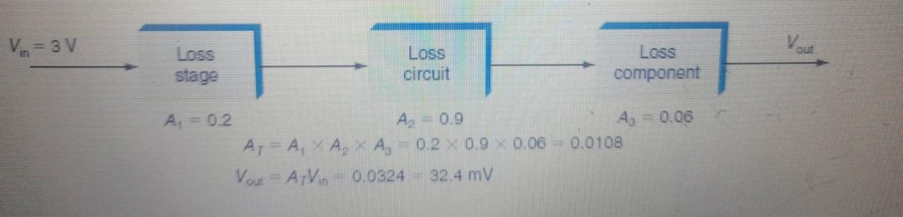

The overall attenuation is

*AT =A*1 x *A*2 x *A*3

With the values shown in above fig, the overall attenuation is

*AT* = 0.2 x 0.9 x 0.06 = 0.0108

Given an input of 3 V, the output voltage is

*V*out = *AT V*in =0.0108x3=0.0324 = 32.4 mV

It is common in communication systems and equipment to cascade circuits and

components that have gain and attenuation. For example, loss introduced by a circuit can be compensated for by adding a stage of amplification that offsets it.

The overall gain or attenuation of the circuit is simply the product of the attenuation and gain factors.

Another example is shown in fig below which shows two attenuation circuits and two amplifier circuits. The individual gain and attenuation factors are given.

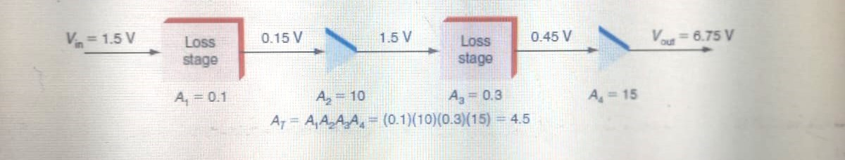

The overall gain or attenuation is *A*= *A*1 *A*2 *A*3 *A*4 = (0.1) (10) (0.3) (15) = 4.5

In this example, the overall circuit has a net gain since A>1. But in some instances, the overall circuit or system may have a net loss. In any case, the overall gain or loss is obtained by multiplying the individual gain and attenuation factors.

**Ex:**  An amplifier has a gain of 45,000, which is too much for the application. With an input voltage of 20 *μ*V, what attenuation factor is needed to keep the output voltage from exceeding 100 mV?

Let *A*1= amplifier gain =45,000;

*A*2 = attenuation factor; *AT* = total gain.

**Sol:**

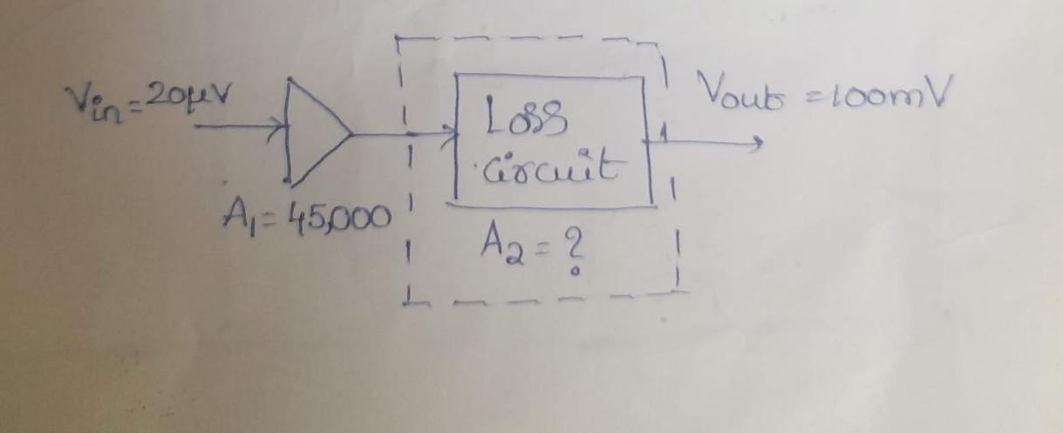

*A*T=*V*out= 100mV =5000; A1=45,000

*V*in 20*μ*V

AT= A1x A2=5000

A2 =AT/A1= 500/45000= 0.11

**Decibels**

The gain or loss of a circuit is usually expressed in *decibels (dB)*, a unit of measurement that was originally created as a way of expressing the hearing response of the human ear to various sound levels. A decibel is one-tenth of a bel. When gain and attenuation are both converted to decibels, the overall gain or attenuation of an electronic circuit can be computed by simply adding the individual gains or attenuations, expressed in decibels.

It is common for electronic circuits and systems to have extremely high gains or

attenuations, often in excess of 1 million. Converting these factors to decibels and using logarithms result in smaller gain and attenuation figures, which are easier to use.

**Decibel Calculations.** The formulas for computing the decibel gain or loss of a circuit are

dB = 20 log *V*out

*V*in  (1)

dB = 20 log *I*out

*I*in (2)

dB =10 log *P*out

*P*in  (3)

Formula (1) is used for expressing the voltage gain or attenuation of a circuit; Formula (2), for current gain or attenuation. The ratio of the output voltage or current to the input voltage or current is determined as usual. The base-10 or common log of the Output/input ratio is then obtained and multiplied by 20. The resulting number is the gain or attenuation in decibels.

Formula (3) is used to compute power gain or attenuation. The ratio of the power output to the power input is computed, and then its logarithm is multiplied by 10.

**Ex:**  An amplifier has an input of 3 mV and an output of 5 V. What is the gain

in decibels?

**Sol:** dB = 20 log (5/0.003)

=20 log (1666.67)

=20(3.22)

= 64.4

**Ex:** A two-stage amplifier has gain of 200 for first stage and 100 for second stage. Express

overall gain in dB?

**Sol:** First stage gain, A1=200

First stage gain in dB= 20 log (200)= 20x2.301=46.02

Second stage gain=A2= 100

Second stage gain in dB= 20 log(100)= 20x2=40

Overall gain = A1xA2

Overall gain in dB = A1 in dB+A2 in dB

= 46.02+40

= 86.02 dB

**Ex:** A filter has a power input of 50 mW and an output of 2 mW. What is the gain or attenuation?

**Sol:** dB = 10 log (2m/50m)

= 10 log 0.04

= 10(-1.398)

= -13.98

When the circuit has gain, the decibel figure is positive. If the gain is

less than 1, which means that there is an attenuation, the decibel figure is negative.

Now, to calculate the overall gain or attenuation of a circuit or system, we simply add the decibel gain and attenuation factors of each circuit.

An example is shown in fig below, where there are two gain stages and an attenuation block.

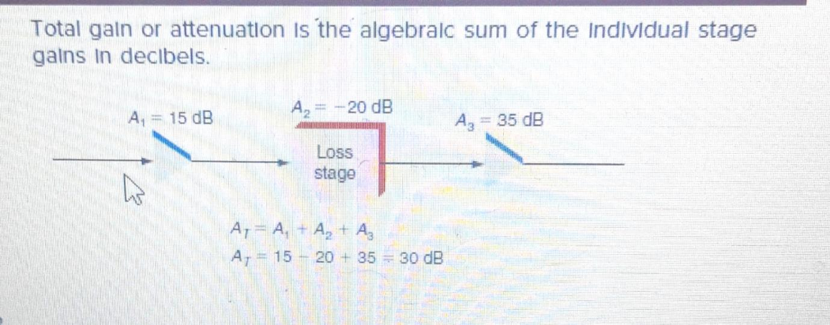

The overall gain of this circuit is

*AT* = *A*1 - *A*2 + *A*3 = 15 - 20 + 35 = 30 dB

**Ex:** A Communication system has five stages with gains of 12, 245, 68, 231 and attenuation of 9dB. What is the overall gain or attenuation in dB ?

**Sol:** First stage gain, A1=12

First stage gain in dB= 20 log (12) = 20x1.079=21.58

Second stage gain=A2= 245

Second stage gain in dB= 20 log (245) = 20x2.389=47.78

Third stage gain, A3=68

Third stage gain in dB= 20 log (68) = 20x1.83=36.65

Fourth stage gain=A4= 231

Fourth stage gain in dB= 20 log (231) = 20x2.36=47.27

Fifth stage attenuation=A5=9dB (loss, negative)

The overall gain or attenuation in dB= A1+ A2+ A3+ A4-A5 (in dB)

= 21.58+47.78+36.65+47.27-9

= 144.28 dB

Since the value is positive, the overall cascaded system is said to have a gain of

144.28 dB.

**Antilogs**

To calculate the input or output voltage or power, given the decibel gain

or attenuation and the output or input, the *antilog* is used. The antilog is the

number obtained when the base is raised to the logarithm, which is the exponent:

dB = 10 log *P*out

*P*in

and dB= log *P*out

10  *P*in

And *P*out= antilog dB=log-1dB

*Pin* 10 10

The antilog is simply the base 10 raised to the dB/10 power.

**Ex:** A power amplifier with a 40-dB gain has an output power of 100 W. What is the input power?

**Sol:** dB = 10 log *P*out

*P*in antilog = log -1

dB = log Pout

10 Pin

40= log Pout

10 Pin

4= log Pout

Pin

log -1(4)= Pout

Pin

10,000= Pout

Pin

10000= 100

Pin

Pin = 100

10000

= 0.01=10mW

**FREQUENCY TRANSLATION**

Frequency translation is the process of shifting a signal from one frequency to another, without loss of information in the signal. This is useful in any application that does take into account at what frequency the information signal is transmitted. This is frequently used in wireless communication system. We can increase or decrease the frequency of the information signal using frequency translation. The mixer is generally used to perform the frequency translation method. If the output signal frequency is higher than the input signal frequency then it is known as up-conversion. If the output signal frequency is lower than the input signal frequency then it is known as down-conversion.

**NEED FOR MODULATION**

In radio transmission, it is necessary to send audio signal from a broadcasting station over great distance to a receiver. This communication of audio signal does not employ any wire and it is a wireless communication. The audio signal cannot be sent directly over air for longer distance. Even if the audio signal is converted to electrical signal, it cannot be sent very far without employing large amount of power. The energy of the wave is directly proportional to its frequency. At audio frequencies (20Hz to 20 kHz), the signal power is quite small and radiation is not practicable.

The radiation of electrical energy is practicable only at high frequencies (above 20kHz). The high frequency signals can be sent thousands of miles even with comparatively small amount of power. Therefore if the audio signal is to be transmitted properly, some means must be incorporated which will permit transmission to occur at high frequencies while it simultaneously allows the carrying of audio signal. This is achieved by super imposing the electrical audio signal on a high frequency carrier. The resultant waves are known as modulated waves and the process is called **modulation.** At the receiver side, the audio signal is extracted from the modulated wave by the process called **demodulation.**

In modulation, either the amplitude, frequency or phase of the high frequency wave called the carrier signal is varied in accordance with amplitude value of information signal (audio signal).

**NEED FOR MODULATION**

The audio signals have a frequency range from 20Hz to 20 kHz. These low frequency signals cannot be transmitted directly into space without modulation due to the following reasons.

1. **Practical antenna length:**

For the transmission of radio signals, the antenna height must be multiple of λ/4, where

λ is the wavelength.

λ = c /f where c is the velocity of light and f is the frequency of the signal

to be transmitted.

The minimum antenna height required to transmit a baseband signal of f = 15 kHz is calculated as follows:

H =λ/4=c/4f=(3x108)/(4x15x1000)=5000m

The antenna of this height is practically impossible to install. We observe that as we are operating with low frequency signals then the height of the antenna required to transmit those signal is of 5000 meters. The design of this type of antenna is practically impossible so if we increase the frequency of signal then we can reduce the height of antenna but practically our message signal is of low frequency so we use a high frequency carrier and imparts our low frequency message in that carrier which makes transmitting signal as high frequency

Now, let us consider a modulated signal at f = 1MHz. The minimum antenna height is given by,

H =λ/4=c/4f= (3x108)/(4x1x1000000)=75m

Setting up a vertical antenna of this length is practically possible.

If a carrier wave of 1MHz is used to carry the signal (modulation is done), the length of the antenna comes out to be 75m only and this size can be easily constructed.

1. Range of Communication:

The frequency of audio signal is low and the low frequency signals cannot travel long distance when they are transmitted. They get heavily attenuated. The attenuation reduces with increase in frequency of the transmitted signal, and they travel longer distance. The modulation process increases the frequency of the signal to be transmitted. Therefore, it increases the range of communication.

1. Quality of Reception:

With frequency modulation (FM) and the digital communication techniques such as PCM, the effect of noise is reduced to a great extent. And because of the high frequency carrier, we can protect information from various disturbances and we will get information without any loss. This improves quality of reception..

1. **Mixing up of signals from different transmitters:**

All the audio signals from different transmitters have the same frequency range. If the audio signals from different transmitters directly, they will get mixed up and there is no way to distinguish between them. This difficulty can be solved by allotting different carrier frequencies to different transmitting stations.

1. **Effective power radiated by the antenna:**

For a linear antenna of length l, the power radiated is

P ∞ (l/ λ)2

For the same antenna length l, the power radiated will be large for signals of shorter wavelengths or higher frequencies. For good transmission, we need high powers. This requires the transmission to be carried out at high frequencies. For this reason, we use high frequency carrier wave to carry the audio signal.